**MAXIMUM POWER-POINT TRACKING (MPPT) IN WIND-ENERGY CONVERSION SYSTEMS USING MACHINE LEARNING**

SIDDARTH SREENI

2014A3PS250G

SAHITYA TAHILIANI

2014A8PS775G

**The report is being submitted for partial requirement of the course**

DESIGN ORIENTED PROJECT   
(EEE_INSTR_F377)

**Under the supervision of:**  
Dr. C. Balakrishna Moorthy,

Dept. of Electrical and Electronics Engineering.



**BITS-Pilani K.K. Birla Goa Campus**

Contents

1. KEYWORDS: 3

2. ABSTRACT: 3

3. WIND ENERGY AND ITS IMPORTANCE: 4

4. WIND-ENERGY CONVERSION SYSTEMS: 5

5. MAXIMUM POWER POINT TRACKING: 6

6. COMMON METHODS USED FOR MPPT: 7

6.1 Perturb and observe 7

6.2 Incremental conductance 8

6.3 Current sweep 8

6.4 Constant voltage 8

6.5 Fuzzy Logic Control 9

6.6 Neural Network 9

7. COMPARISION BETWEEN DIFFERENT MPPT TECHNIQUES: 10

8. IMPLEMENTED ALGORITHM: 10

9. MACHINE LEARNING 11

9.1 LINEAR REGRESSION MODEL (MACHINE LEARNING USED): 12

9.1.1 Model Representation 12

9.1.2 Making Predictions with Linear Regression 13

10. DESIGN PARAMETERS: 15

10.3 METHODOLOGY: 15

10.3.1 INPUTS USED: 15

10.4 METHOD: 16

11. EQUATIONS AND APPROXIMATIONS USED IN THE PROPOSED DESIGN: 16

11.1 Terminology Used: 17

11.2 Equations Formulated: 17

12. MATLAB SIMULATION: 17

13. THE PERTURB AND OBSERVE ALGOORITHM SIMULATION IN MATLAB: 19

13.1. Basic Power Vs Load curve at 300 and 900 rpm 19

13.2. Error Encountering and Tackling: 20

13.3. MPPT from simulation and ML. 21

14. STATISTICS: 21

15.CONCLUSION 21

REFERENCES: 22

# 

# 1. KEYWORDS:

Wind Energy Conversion Systems, Power Electronics, MPPT (Maximum Power Point Tracking), Machine Learning.

# 2. ABSTRACT:

This project was done to obtain an efficient and feasible algorithm to extract the maximum power point by implementing Machine Learning (ML) into Perturb and Observe(P&O). In this report, we explain the advantages of using Machine learning as a modified Hill Climb Search algorithm to obtain the maximum power point. The Controller circuit is a digitalized controller coded in High Level Language Python. This takes in previously recorded data and logs in the data captured. The controller hence forth referred to as the Machine starts learning from the data logged and starts predicting the values closer to the Maximum Practical Achievable Power. As time progresses by, the machine becomes accurate and adapts to the versatile environment conditions. As of now, we have achieved a simulation of the same in python.

# 3. WIND ENERGY AND ITS IMPORTANCE:

Wind is a form of "**SOLAR ENERGY"**. Winds are caused by the uneven heating of the atmosphere by the sun, the irregularities of the earth's surface, and rotation of the earth. Wind flow patterns are modified by the earth's terrain, bodies of water, and vegetative cover. This wind flow, or motion energy, when "harvested" by modern **wind turbines**, can be used to generate **electricity**.

The costs of mining and transporting fossil fuels and nuclear power are highly variable, and the cost of electricity from these sources often fluctuates. Many experts consider wind power a viable alternative to buffer these costs because wind is fixed and free. The use of wind-generated electricity promotes cost-effective and renewable production of energy. Moreover, it reduces dependence on fossil fuel.

The benefits of wind energy are numerous. Wind energy is home grown, and local landowners and small businesses can operate single turbines or clusters of turbines. It doesn't emit contaminants into lakes and streams, and it doesn't produce hazardous airborne pollutants. Wind energy doesn't cause acid rain or contribute to global climate change. Most other sources of power, including natural gas and coal, produce greenhouse gases, whereas wind energy produces none. Wind energy has a minimal impact on crop production and livestock grazing as well, because wind farms cover only small areas of land.

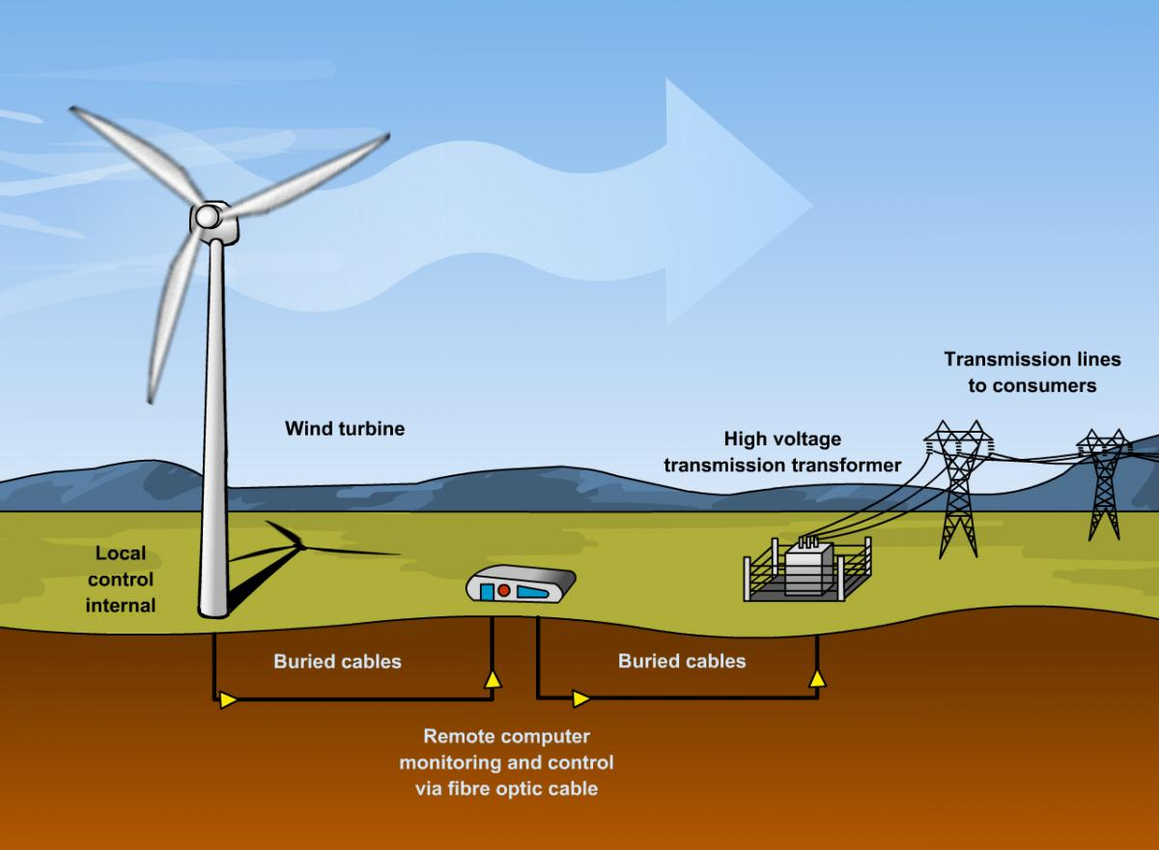

Fig-1: Overview of a Wind farm [1]

# 

# 4. WIND-ENERGY CONVERSION SYSTEMS:

An apparatus for converting the kinetic energy available in the wind to mechanical energy that can be used to power up machinery (grain mills, water pumps, etc.) and/or to operate an electrical generator. Thanks to extensive research and development efforts during the past 30 years, wind energy conversion has become a reliable and competitive means for electric power generation. The life span of modern wind turbines is now 20-25 years, which is comparable to many other conventional power generation technologies. The average availability of commercial wind power plants is now around 98%. The cost of wind power has continued to decline through technological development, increased production level, and the use of larger turbines. 

The major components of a typical wind energy conversion system include a wind turbine, a generator, interconnection apparatus, and control systems. At the present time and for the near future, generators for wind turbines will be synchronous generators, permanent magnet synchronous generators, and induction generators, including the squirrel-cage type and wound rotor type. For small to medium power wind turbines, permanent magnet generators and squirrel-cage induction generators are often used because of their reliability and cost advantages. Induction generators, permanent magnet synchronous generators, and wound field synchronous generators are currently used in various high power wind turbines.   
  
Interconnection apparatuses are devices to achieve power control, soft start, and interconnection functions. Very often, power electronic converters are used as such devices. Most modern turbine inverters are forced commutated PWM inverters to provide a fixed voltage and fixed frequency output with a high power quality. Both voltage source voltage controlled inverters and voltage source current controlled inverters have been applied in wind turbines. For certain high power wind turbines, effective power control can be achieved with double PWM (pulse-width modulation) converters which provide a bidirectional power flow between the turbine generator and the utility grid.

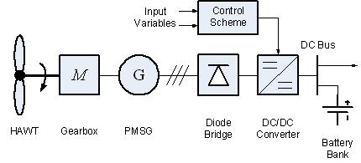

Fig2: A typical Wind-Energy Conversion System (HAWT-Horizontal Axis Wind Turbine) [2]

# 5. MAXIMUM POWER POINT TRACKING:

**Maximum power point tracking** (**MPPT**) is a technique used commonly with wind turbines and photovoltaic solar systems to maximize power extraction under all conditions.

Although solar power is mainly considered, the principle applies generally to all sources with variable power including WECS (WIND ENERGY CONVERSION SYSTEMS).

The central problem addressed by MPPT is that the efficiency of power transfer from the wind turbine depends on both the Wind-speed and the electrical characteristics of the load. As the wind-speed varies, the load characteristic that gives the highest power transfer efficiency changes, so that the efficiency of the system is optimized when the load characteristic changes to keep the power transfer at highest efficiency. This load characteristic is called the maximum power point and MPPT is the process of finding this point and keeping the load characteristic there. Electrical circuits can be designed to present arbitrary loads to the wind-turbine and then convert the voltage, current, or frequency to suit other devices or systems, and MPPT solves the problem of choosing the best load to be presented to the cells in order to get the most usable power out.

Wind energy power output can be analyzed based on the I-V curve [3]. It is the purpose of the MPPT system to sample the output of the wind turbine and apply the proper resistance (load) to obtain maximum power for any given environmental conditions. MPPT devices are typically integrated into an electric power converter system that provides voltage or current conversion, filtering, and regulation for driving various loads, including power grids, batteries, or motors.

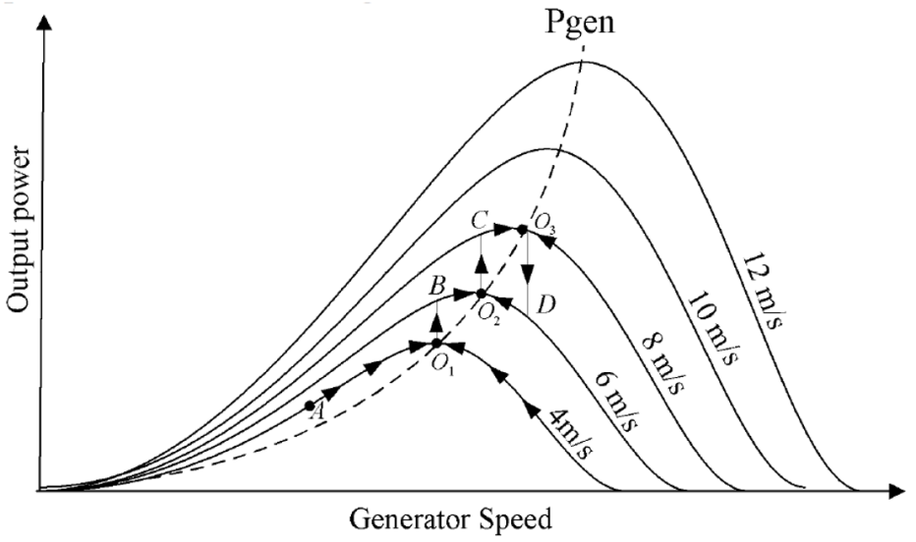

Fig-3: Output power vs. generator speed curve for a wind turbine (showing different maximum power-points O1,O2,O3 for different values of wind speed) [4]

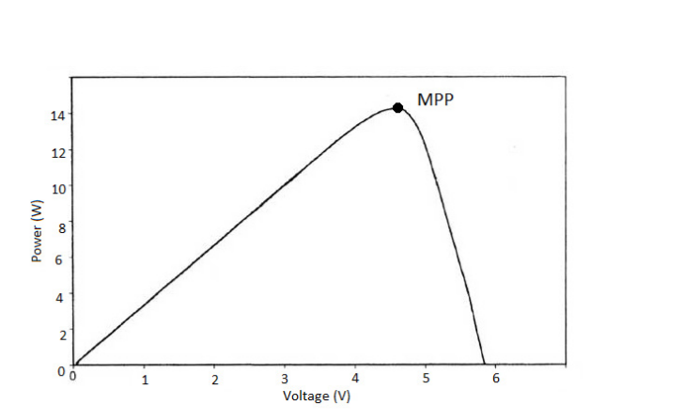

Fig-4: P-V characteristics curve of a Wind-Turbine (depicting Maximum Power-Point) [5]

# 6. COMMON METHODS USED FOR MPPT:

## 6.1 Perturb and observe

In this method the controller adjusts the voltage by a small amount from the generator (Permanent Magnet Synchronous generator) load and measures power. If the power increases, further adjustments in that direction are tried until power no longer increases. This is called the perturb and observe method and is most common, although this method can result in oscillations of power output. [6] It is referred to as a **Hill climbing method**, because it depends on the rise of the curve of power against voltage below the maximum power point, and the fall above that point. Perturb and observe is the most commonly used MPPT method due to its ease of implementation. Perturb and observe method may result in top-level efficiency, provided that a proper predictive and adaptive hill climbing strategy is adopted.

## 6.2 Incremental conductance

In the incremental conductance method, the controller measures incremental changes in generator (PMSG) current and voltage to predict the effect of a voltage change. This method requires more computation in the controller, but can track changing conditions more rapidly than the perturb and observe method (P&O). Like the P&O algorithm, it can produce oscillations in power output [7].This method utilizes the incremental conductance (dI/dV) of the generator to compute the sign of the change in power with respect to voltage (dP/dV).

The incremental conductance method computes the maximum power point by comparison of the incremental conductance (IΔ / VΔ) to the generator conductance (I / V). When these two are the same (I / V = IΔ / VΔ), the output voltage is the MPP voltage. The controller maintains this voltage until the wind-speed changes and the process is repeated.

## 6.3 Current sweep

The current sweep method uses a sweep waveform for the generator such that the I-V characteristic is obtained and updated at fixed time intervals. The maximum power point voltage can then be computed from the characteristic curve at the same intervals. [8]

## 6.4 Constant voltage

The term "constant voltage" in MPP tracking is used to describe different techniques by different authors, one in which the output voltage is regulated to a constant value under all conditions and one in which the output voltage is regulated based on a constant ratio to the measured open circuit voltage (VOC). The latter technique is referred to in contrast as the "open voltage" method by some authors .If the output voltage is held constant, there is no attempt to track the maximum power point, so it is not a maximum power point tracking technique in a strict sense, though it does have some advantages in cases when the MPP tracking tends to fail, and thus it is sometimes used to supplement an MPPT method in those cases.

In the "constant voltage" MPPT method (also known as the "open voltage method"), the power delivered to the load is momentarily interrupted and the open-circuit voltage with zero current is measured. The controller then resumes operation with the voltage controlled at a fixed ratio, such as 0.76, of the open-circuit voltage VOC. [9]  This is usually a value which has been determined to be the maximum power point, either empirically or based on modeling, for expected operating conditions. The operating point of the generator is thus kept near the MPP by regulating the voltage and matching it to the fixed reference voltage Vref=kVOC. The value of Vref may be also chosen to give optimal performance relative to other factors as well as the MPP, but the central idea in this technique is that Vref is determined as a ratio to VOC.

One of the inherent approximations to the "constant voltage" ratio method is that the ratio of the MPP voltage to VOC is only approximately constant, so it leaves room for further possible optimization.

## 6.5 Fuzzy Logic Control

Microcontrollers have made using fuzzy logic control popular for MPPT over last decade. Fuzzy logic controllers have the advantages of working with imprecise inputs, not needing an accurate mathematical model, and handling nonlinearity. [10]

## 6.6 Neural Network

Another technique of implementing MPPT which are also well adapted for microcontrollers is neural networks. Neural networks commonly have three layers: input, hidden, and output layers. The number nodes in each layer vary and are user-dependent. The input variables can be generator parameters like VOC and ISC, atmospheric data like wind-speed and temperature, or any combination of these. The output is usually one or several reference signals like a duty cycle signal used to drive the power converter to operate at or close to the MPP [10].

# 7. COMPARISION BETWEEN DIFFERENT MPPT TECHNIQUES:

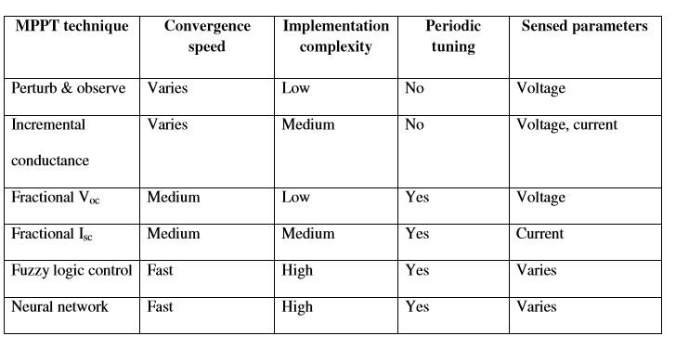

Table 1: Compares different MPPT techniques on different parameters. [10]

# 8. IMPLEMENTED ALGORITHM:

We chose Perturb and Observe Method for implementation in Machine learning since it is the most widely used method because of its ease, and is feasible to implement due to its low complexity. It doesn’t require constant tuning and gives very high accuracy compared to other algorithms. Hence, the controller will adjust the voltage by a small amount from the predicted value by altering generator load and measuring power. If the power increases, further adjustments in that direction are tried until the power no longer increases, thereby achieving maximum power point.

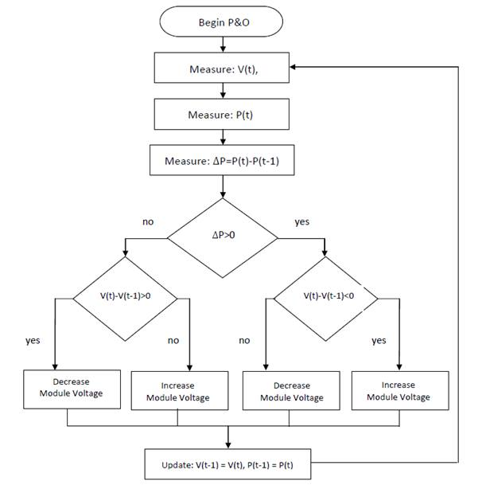

Fig-5: Flowchart depicting Perturb and Observe Algorithm

# 9. MACHINE LEARNING

Machine learning is a type of artificial intelligence ([AI](http://searchcio.techtarget.com/definition/AI)) that provides computers with the ability to learn without being explicitly programmed. Machine learning focuses on the development of computer programs that can teach themselves to grow and change when exposed to new data.

The process of machine learning is similar to that of data mining. Both systems search through data to look for patterns. However, instead of extracting data for human comprehension -- as is the case in data mining applications -- machine learning uses that data to detect patterns in data and adjust program actions accordingly.  Machine learning algorithms are often categorized as being supervised or unsupervised. Supervised algorithms (proposed) can apply what has been learned in the past to new data. Unsupervised algorithms can draw inferences from datasets. Behind the scenes, the software is simply using statistical analysis and predictive analytics to identify patterns in the data generated.

## 9.1 LINEAR REGRESSION MODEL (MACHINE LEARNING USED):

Linear regression assumes a linear relationship between the input variables (x) and the single output variable (y). More specifically, that y can be calculated from a linear combination of the input variables (x).

When there is a single input variable (x), the method is referred to as**Simple linear regression**. When there are **multiple input variables**, literature from statistics often refers to the method as multiple linear regression.

Different techniques can be used to prepare or train the linear regression equation from data.

### 9.1.1 Model Representation

[Linear regression](https://en.wikipedia.org/wiki/Linear_regression) is an attractive model because the representation is so simple.

The representation is a linear equation that combines a specific set of input values (x) the solution to which is the predicted output for that set of input values (y). As such, both the input values (x) and the output value are numeric.

The linear equation assigns one scale factor to each input value or column, called a coefficient and represented by the capital Greek letter Beta (B). One additional coefficient is also added, giving the line an additional degree of freedom (e.g. moving up and down on a two-dimensional plot) and is often called the intercept or the bias coefficient.

y = B0 + B1*X1 + B2*X2 + … + Bn*Xn - (general equation)

For example, in a simple regression problem (a single x and a single y), the form of the model would be:

y = B0 + B1 * (x) …………(1)

In higher dimensions when we have more than one input (x), the line is called a plane or a hyper-plane. The representation therefore is the form of the equation and the specific values used for the coefficients (e.g. B0 and B1 in the above example).

It is common to talk about the complexity of a regression model like linear regression. This refers to the number of coefficients used in the model.

When a coefficient becomes zero, it effectively removes the influence of the input variable on the model and therefore from the prediction made from the model (0 * x = 0). This becomes relevant if you look at regularization methods that change the learning algorithm to reduce the complexity of regression models by putting pressure on the absolute size of the coefficients, driving some to zero. [11]

### 9.1.2 Making Predictions with Linear Regression

Given the representation is a linear equation, making predictions is as simple as solving the equation for a specific set of inputs.

Let’s make this concrete with an example. Imagine we are predicting weight (y) from height (x). Our linear regression model representation for this problem would be:

y = B0 + B1 *(x1) ……..(2)

or

Weight =B0 +B1 *(height) ……..(3)

Where B0 is the bias coefficient and B1 is the coefficient for the height column. We use a learning technique to find a good set of coefficient values. Once found, we can plug in different height values to predict the weight.

For example, let’s use B0 = 0.1 and B1 = 0.5. Let’s plug them in and calculate the weight (in kilograms) for a person with the height of 182 centimeters.

=>Weight = 0.1 + 0.05 * 182

=>Weight = 91.1

You can see that the above equation could be plotted as a line in two-dimensions. The B0 is our starting point regardless of what height we have. We can run through a bunch of heights from 100 to 250 centimeters and plug them to the equation and get weight values, creating our line. [11]

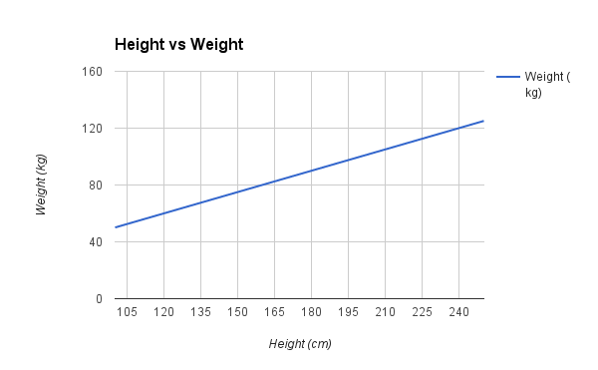

Fig-6. Graph between height and Weight from the example [11]

# 10. DESIGN PARAMETERS:

Maximum Power Point Tracking and Grid feeding of Permanent Magnet Synchronous (simulation MATLAB) – DC Generator (Python) based Wind Energy Conversion System Using Modified Hill Climb Searching Algorithm.

* 1. **INPUTS USED:** 
     1. Wind Speed

**10.1.2** Rotor Speed

* 1. **PARAMETERS INVOLVED:**
     1. Voltage peak
     2. Current peak
     3. Resistance, Inductance, Torque
     4. Speed (ω)
     5. Flux Linkage
     6. Rotor Inertia
     7. Noise

## 10.3 METHODOLOGY:

The MPP of the next instant on an ongoing WECS is calculated from previous data analysis by predicting the output load by means of machine learning and starting a hill climb search from this obtained output load. This reduces the time taken for doing an entire HCS from start.

### 10.3.1 INPUTS USED:

* Wind Speed (as RPM)
  + Considering Constant Tip Speed Ratio (λ) [12]
* Air Density (to be used)
* Area Perpendicular to the flow of Wind (to be used)
* Power Coefficient (to be used)
* Pressure at Height of turbine
* Temperature
* Humidity

## 10.4 METHOD:

Follows a vigorous hill climb search for the maximum power point starting from the value obtained from the regression model with a precision of 10-3The corrected Value is re-updated into the training data for improving the accuracy of the system.

For the simulation of values and data, the following values were taken:

Ka = 50 units

Kf = 0.01 units

If = 2A

Rf = 1 Ώ

Ra = 3 Ώ

The data for various wind speed, temperature, humidity, pressure etc. was obtained from BITSPilani, K.K. Birla Goa Campus’ in campus data provided.

# 11. EQUATIONS AND APPROXIMATIONS USED IN THE PROPOSED DESIGN:

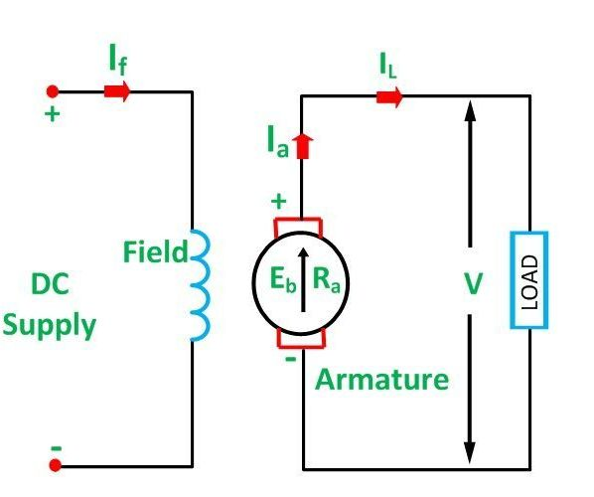

Fig-7 Diagram of Separately excited DC Generator [13]

## 11.1 Terminology Used:

Eb-Armature Voltage

Ra-Armature Resistance

IL-Load Current

RL-Load Resistance

If-Field Current

V-Voltage Across Load

Kf-Field Constant

Ka-Armature Constant

w-rotor speed (RPM)

## 11.2 Equations Formulated:

(Considering separately excited DC generator and taking necessary assumptions):

V=EbxRL/(Ra+RL) ……..(4)

IL= Eb/(Ra+RL)…. ……..(5)

Eb=(Kf)x(Ka)x(If)x(w)…. ……..(6)

Hence, the formulated equation for Power generated is: P=(V)x(IL)

P(Power)= [(Kf)x(Ka)x(If)x(w)/(Ra+RL)]2x(RL) …….(7) …..(using equations 4,5,6) [14]

# 12. MATLAB SIMULATION:

The MATLAB simulation takes inputs of the generator speed, pitch angle [constant], wind-speed to the turbine and generates Torque(Tm) for the PMSG (Permanent Magnet Synchronous Generator).

A permanent magnet synchronous generator is a generator where the excitation field is provided by a permanent magnet instead of a coil. The term synchronous refers here to the fact that the rotor and magnetic field rotate with the same speed, because the magnetic field is generated through a shaft mounted permanent magnet mechanism and current is induced into the stationary armature.

PMSG being an AC Machine in nature generates three-phase output which is converted to DC using a universal bridge. Finally, DC Values of Current and Voltage are generated which account for a power statistic. This Generated Power is altered by variable impedance (Resistance for the proof of concept) which results in an increment/decrement in the Voltage/Current.

Hence,

The results from the P&O algorithm will be given as input into the regression model equation in ML to solve and determine an optimum power generating load for different input parameters mentioned in **10.2**

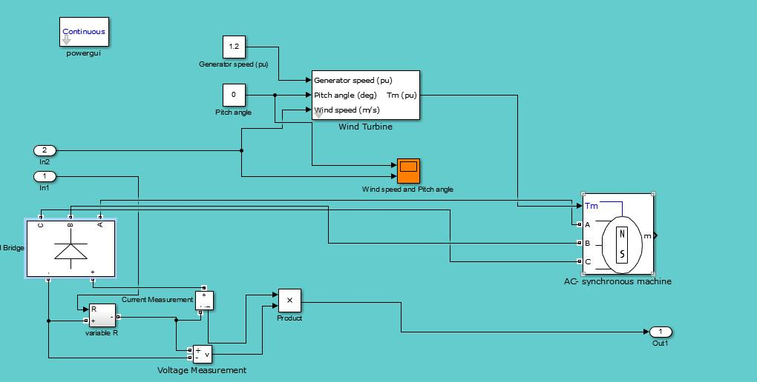

Fig-8. The following arrangement simulates the working of an ideal wind turbine and generates power accordingly using a simple PMSG circuitry using a bridge in MATLAB

# 13. THE PERTURB AND OBSERVE ALGORITHM SIMULATION IN MATLAB:

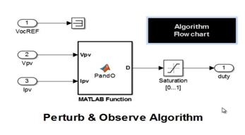

Fig-9 Algorithm Tracks MPP by varying voltage and checking power output after each sample.

## 13.1. Basic Power Vs Load curve at 300 and 900 rpm

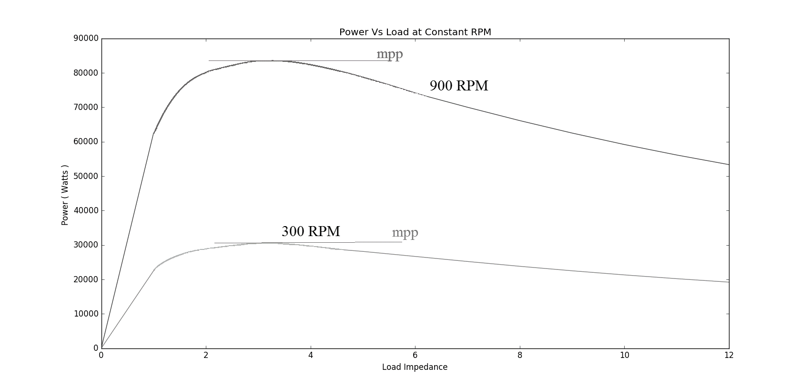

Fig-10 MPPT of two Power Vs. Impedance graphs at 300 and 900 RPM.

The above graph plots the power obtained from the simulation for different loads impedance supplied at a constant separately excited generator at speeds of 300 RPM and also 900RPM.

## 13.2. Error Encountering and Tackling:

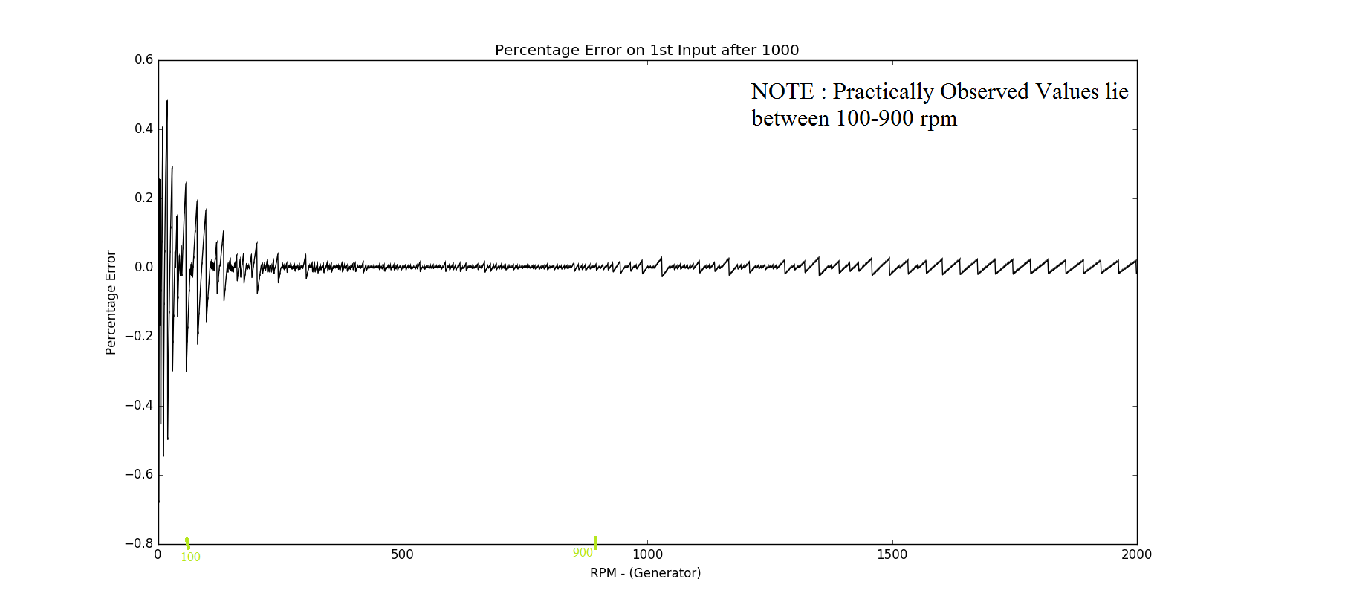

Fig 11 – Error between the predicted and actual MPP.

The graph mentions the deviation from the actual value to the predicted value at different wind speeds, assuming (T+1) th Wind speed can a lie between in effect to (0 – 2000+) RPM of the generator. This additionally is just showing that the error comes to around less than a factor of 0.6% for the realisable conditions extrapolating linearly for the non-realisable regions.

**Note:** The predicted model error value is NOT fed into the standard charger controller. The value is taken to obtain a load and a hill climb search is done near that load to quickly obtain a Maximum Power Point as explained under **Methodology**. **(10.2.)**

13.3. MPPT from simulation and ML.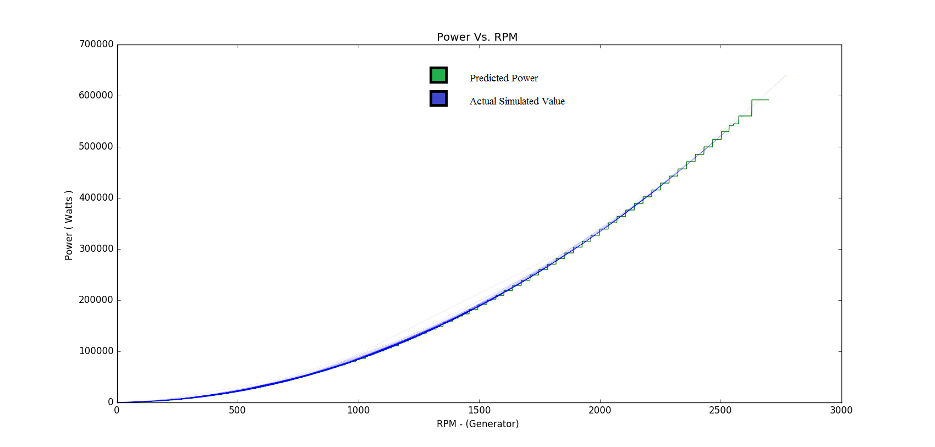Fig -12. Depicts the slight variation of ML values towards MPPT (actual)

# 14. STATISTICS:

Time taken for Calculating MPP from Predicted Load Impedances:

= ~ **0.313 / 2500 calculations**

= ~ **0.0001252 seconds/per MPP calculation**

which is realisable, compared to the amount of calculations it will be doing in real-time.

# 15.CONCLUSION

* The various aspects starting from simulation of the turbine in MATLAB to obtaining the maximum power point using HCS and ML was implemented.
* A code generator was used to obtain the corrective equations from MATLAB for the equations.
* A python script was run to obtain faster and efficient results based on the computers efficiency.
* The Linear_regression_model from scikit library was used to do the training of given data.
* Matplotlib in python was used to plot the graphs depicted. (Fig, 10,11,12)

# REFERENCES:

|  |  |
| --- | --- |
| [1] | L. Alt E Wind & Solar, "http://www.altewindandsolar.com/ResidentialWind.html," [Online]. |
| [2] | C. 6-D and A. -. Chile, "http://www.scielo.cl/scielo.php?script=sci_arttext&pid=S0718-33052009000300006," [Online]. |
| [3] | M. Seyedmahmoudian, A. Mohamadi, S. Kumary, A. M. T. Oo and A. Stojcevski, A Comparative Study on Procedure and State of the Art of Conventional Maximum Power Point Tracking Techniques for Photovoltaic System. |
| [4] | S. M., C. A. and S. B, "Sensorless power maximization of PMSG based iso‐lated wind-battery hybrid system using adaptive neuro-fuzzy controller," *IEEE Indus‐try Applications Society Annual Meeting ,IAS 2010,* 3-7 October 2010. |
| [5] | D. Marcelo, Comprehensive approach to modeling and simulation of Photovoltaic arrays. |
| [6] | "http://ussolarinstitute.com/glossary/maximum-power-point-tracking/," Solarbuildings.ca. [Online]. |
| [7] | U. o. A. Wang.X, *Control Design for Distributed Photovoltaic Systems,* 2004. |
| [8] | Hart, Branz and Cox, "Experimental tests of open-loop maximum-power-point tracking techniques," *Solar Cells,* vol. 13, p. 185–195, 1984. |
| [9] | S. Ferdous, M. A. Mohammad, F. Nasrullah, A. M. Saleque and A. Muttalib, "Design and simulation of an open voltage algorithm based maximum power point tracker for battery charging PV system," in *IEEE*, 20-22 Dec. 2012. |
| [10] | L.Patrick, Comparison of Photovoltaic array maximum power point tracking technique. |
| [11] | J. Brownlee, "http://machinelearningmastery.com/linear-regression-for-machine-learning/," [Online]. |
| [12] | M. Ragheb, "Optimal Rotor Tip Speed Ratio," 2014. |
| [13] | "http://circuitglobe.com/types-of-dc-generator-separately-excited-and-self-excited.html," [Online]. |
| [14] | D. P. Kothari and I. G. Nagrath, "Electric Machines," in *Electric Machines 4th Edition*, 2010, p. 907. |
| [15] | V. G. K. Shah, S.Josh and N.Patel, "Maximum Power Point Tracking Methods for Wind and Solar Conversion Systems for Standalone Generation PSIM based Perturb and Observe Method," 2015. |
| [16] | K. E. Johnson, L. Y. Pao, M. J. Balas and L. J. Fingersh, “Control of variable-speed wind turbines: Standard and adaptive techniques for maximizing energy capture, IEEE, 2006. |
| [17] | P. D. Linus Ranjin M, "Maximum Power Point Tracking and Grid feeding of Permanent Magnet Synchronous Generator based Wind Energy Conversion System Using Modified Hill Climb Searching Algorithm," *IET Renewable Power Generation,* vol. 9, no. 6, p. 682 – 689, 2015. |